Black Box Testing

1. Create user account

| **S.No** | **Test Scenario** | **Test Input** | **Expected Output** | **Actual Output** | **Test Result** |
| --- | --- | --- | --- | --- | --- |
| 1 | Invalid email | Username: newuser1  Password: password  Email: gg | Error registering user | Error registering user | Pass |
| 2 | Create user with duplicate username | Username: teslafan001  Password: password  Email: new@gmail.com | Error registering user | Error registering user | Pass |
| 3 | Account created | Username: newuser1  Password: password  Email: new@gmail.com | User registered successfully | User registered successfully | Pass |

1. User Login

| **S.No** | **Test Scenario** | **Test Input** | **Expected Output** | **Actual Output** | **Test Result** |
| --- | --- | --- | --- | --- | --- |
| 1 | Login with wrong username | Username: [test123@gmai.com](mailto:test123@gmai.com)  Password: password | Error logging in | Error logging in | Pass |
| 2 | Login with wrong password | Username: [test@gmail.com](mailto:test123@gmai.com)  Password: password123 | Error logging in | Error logging in | Pass |
| 3 | Login with correct details | Username: [test@gmail.com](mailto:test@gmail.com)  Password: password | Navigate to MainScreen after successful log in | Navigate to MainScreen after successful log in | Pass |
| 4 | Create Account | Click on Create button | Navigate to SignUp Page | Navigate to SignUp Page | Pass |

1. Input Search Requirements + Select Destination

| **S.No** | **Test Scenario** | **Test Input** | **Expected Output** | **Actual Output** | **Test Result** |
| --- | --- | --- | --- | --- | --- |
| 1 | Inputting a destination into the search bar (MAP viewing) | ‘Haw par villa’ | Map to zoom into Haw Par Villa’s location | Map to zoom into Haw Par Villa’s location | Pass |
| 2 | Clicking on a carpark marker  (MAP viewing) | Clicking on a random marker | Carpark details such as Name,  Weekday rate, lots available, parking system, indoor/outdoor and electric shown | Carpark details such as Name,  Weekday rate, lots available, parking system, indoor/outdoor and electric shown | Pass |
| 3 | Clicking on carpark details marker (MAP viewing) | ‘Pasir panjang Road- south buona vista road’ | Route to be displayed from user’s location | Route to be displayed from user’s location | Pass |
|  | Clicking on reset button after route has been shown | Clicking on reset button after route to ‘Pasir panjang Road- south buona vista road’ has been displayed | Route line to disappear | Route line to disappear | Pass |
| 4 | Checking the ‘charging port’ checkbox  (MAP viewing) | Checking the charging port box and watching if a non electric marker disappears from view, such as ‘Pasir panjang Road- south buona vista road’ carpark. | Non electric carpark markets disappear from map | Non electric carpark markets disappear from map | Pass |
| 5 | Choosing ‘indoor’ option using dropdown box  (MAP viewing) | Choosing ‘indoor’ option and watching outdoor car park markers disappear from view. such as ‘Pasir panjang Road- south buona vista road’ carpark. | Outdoor carparks disappear from map | Outdoor carparks disappear from map | Pass |
| 6 | Checking the ‘charging port’ checkbox  (LIST viewing) | Check ‘charging port’ checkbox, and only electric car parks are shown | Car Parks listed all are electric | Car Parks listed all are electric | Pass |
| 7 | Choosing ‘indoor’ option using dropdown box  (LIST viewing) | Choosing ‘indoor’ option and only indoor car parks are shown | Car Parks listed are all indoor | Car Parks listed are all indoor | Pass |

1. Input Feedback

| **S.No** | **Test Scenario** | **Test Input** | **Expected Output** | **Actual Output** | **Test Result** |
| --- | --- | --- | --- | --- | --- |
| 1 | No parking history | NIL | “No parking history found” displayed at dropdown menu for previously visited car parks | “No parking history found” displayed at dropdown menu for previously visited car parks | Pass |
| 2 | Send in feedback | Car park: JALAN BESUT  Rating: 5  Review: “Convenient, great rates.” | Page resets, feedback sent in with average rating updated | Page resets, feedback sent in with average rating updated | Pass |
| 3 | Incomplete feedback (No feedback text provided) | Car park: JALAN BESUT  Rating: 4  Review: “” | Page resets, feedback not sent in | Page resets, feedback not sent in | Pass |

White Box Testing

1. Create user account

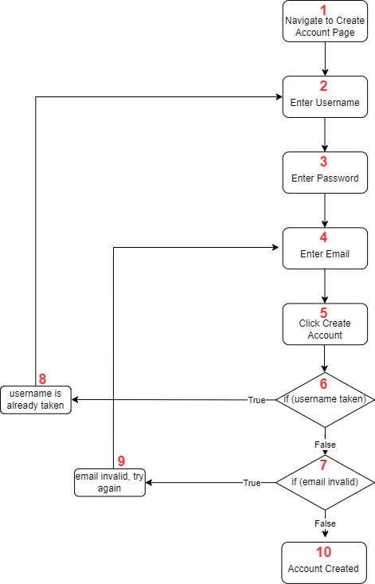

Create user account (cont.)

| **S.No** | **Basis Path** | **Test Case Inputs** |
| --- | --- | --- |
| 1 | 1-7, 10 | Username: newuser1  Password: password  Email: new@gmail.com |
| 2 | 1-6, 8, 2-7, 10 | Username: teslafan001 (error)  Password: password  Email: [newuser@gmail.com](mailto:new@gmail.com)  Username: newuser2  Password: password  Email: newuser2@gmail.com |
| 3 | 1-7, 9, 3-7, 10 | Username: newuser3  Password: password  Email: gg (error)  Email: [newuser3@gmail.com](mailto:new@gmail.com) |

1. User Log In

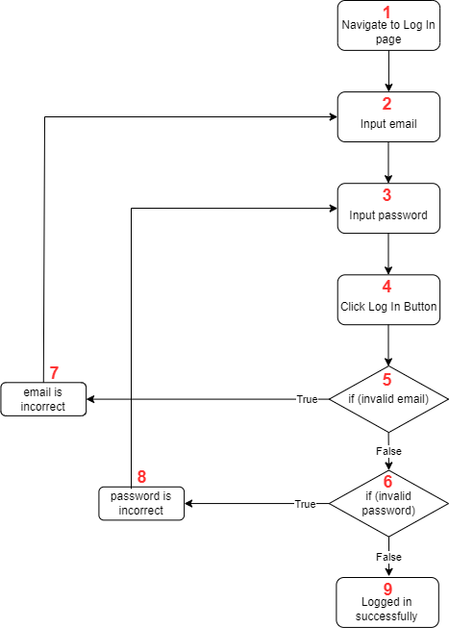

User Log In (cont.)

| **S.No** | **Basis Path** | **Test Case Inputs** |
| --- | --- | --- |
| 1 | 1-6, 9 | Username: [test@gmail.com](mailto:test@gmail.com)  Password: password |
| 2 | 1-5, 7, 2-6, 9 | Username: [test123@gmai.com](mailto:test123@gmai.com) (error)  Password: password  Username: [test@gmail.com](mailto:test@gmail.com)  Password: password |
| 3 | 1-6, 8, 3-6, 9 | Username: [test@gmail.com](mailto:test@gmail.com)  Password: password123 (error)  Password: password |

1. Input Search Requirements + Select Destination

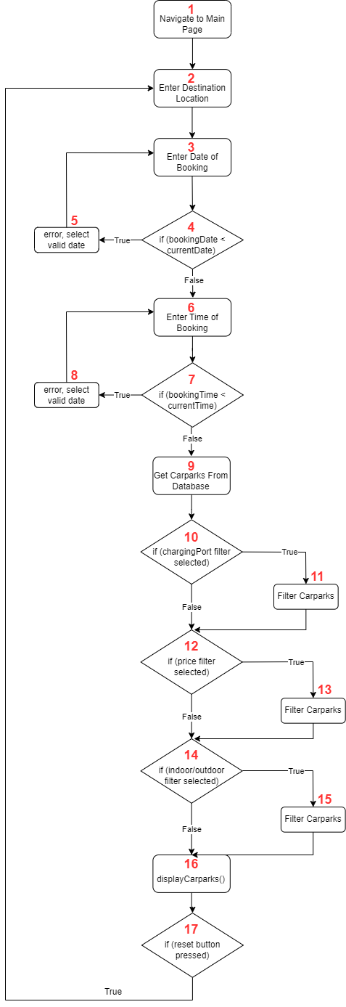

Input Search Requirements + Select Destination (cont.)

| **S.No** | **Basis Path** | **Test Case Inputs** |
| --- | --- | --- |
| 1 | 1-4, 6-7, 9-10, 12, 14, 16 | Destination: “Haw Par Villa”  Date: 16/4/2023  Time: 2100  ChargingPort: no  Price: no  Indoor/Outdoor: no |
| 2 | 1-5, 3-4, 6-7, 9-10, 12, 14, 16 | Destination: “Haw Par Villa”  Date: 10/1/1995 (error)  Date: 17/4/2023  Time: 1500  ChargingPort: no  Price: no  Indoor/Outdoor: no |
| 3 | 1-4, 6-8, 6-10, 12, 14, 16 | Destination: “Haw Par Villa”  Date: 16/4/2023  Time: 0100 (error, time is in the past)  Time: 1500  ChargingPort: no  Price: no  Indoor/Outdoor: no |
| 4 | 1-4, 6-7, 9-12, 14, 16 | Destination: “Haw Par Villa”  Date: 16/4/2023  Time: 1500  ChargingPort: yes  Price: no  Indoor/Outdoor: no |
| 5 | 1-4, 6-7, 9-10, 12-14, 16 | Destination: “Haw Par Villa”  Date: 16/4/2023  Time: 2100  ChargingPort: no  Price: yes  Indoor/Outdoor: no |
| 6 | 1-4, 6-7, 9-10, 12, 14-16 | Destination: “Haw Par Villa”  Date: 16/4/2023  Time: 2100  ChargingPort: no  Price: no  Indoor/Outdoor: yes |

1. Input Feedback

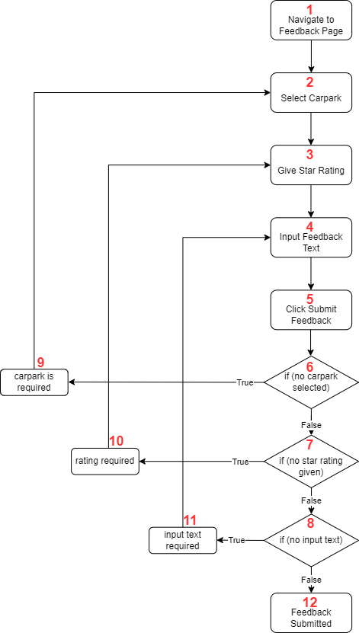

Input Feedback (cont.)

| **S.No** | **Basis Path** | **Test Case Inputs** |
| --- | --- | --- |
| 1 | 1-8, 12 | CarPark: Jalan Besut  Rating: 5  Review: “Convenient, good rates” |
| 2 | 1-6, 9, 2-8, 12 | CarPark: null (error)  Rating: 5  Review: “Nice”  CarPark: Serangoon Gardens  Rating: 5  Review: “Nice” |
| 3 | 1-7, 10, 3-8, 12 | CarPark: Serangoon Gardens  Rating: null (error)  Review: “Decent”  Rating: 3  Review: “Decent” |
| 4 | 1-8, 11, 4-8, 12 | CarPark: Serangoon Gardens  Rating: 4  Review: “” (error)  Review: “Hard to find parking” |